ASSIGNMENT 2 : BASIC STATS 2

***Assignment Tasks***

**a. Build 99% Confidence Interval Using Sample Standard Deviation**

STEP 1: CALCULATE SAMPLE MEAN

X̄ = 1.13 + 1.55 + 1.43 + 0.92 + 1.25 + 1.36 + 1.32 + 0.85 + 1.07+ 1.48 + 1.20 + 1.33 / 15

X̄ = 15.54/15

X̄ = 1.036

STEP 2: CALCULATE SAMPLE STANDARD DEVIATION

​ 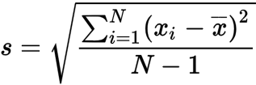

N-1 = 15 -1 = 14

s $≈$ $\sqrt{{(1.13 - 1.036)2 }^{} + (1.55 - 1.036)2 + (0.92- 1.036)2 + (1.25 - 1.036)2 + ...+(1.29 - 1.036)2 }÷ 14$

s $≈$ 0.231

STEP 3: t VALUE FOR 99% CONFIDENCE INTERVAL

Degree of freedom (df) = n -1

= 15 - 1

= 14

$α = 1 - 0.99 = 0.01$

Alpha for each tail = $\frac{0.01}{2} = 0.005$

Now using t calculator, For 99% confidence, the t-value is,

${ t}_{0.005,14 }$ $≈ 2.977$

STEP 4: CALCULATE MARGIN OF ERROR

ME = t $× \frac{s}{\sqrt{n}}$

= 2.977 $× \frac{0.231}{\sqrt{15}}$

$≈ 0.116$

STEP 5: CONFIDENCE INTERVAL

= $\underline{(x } - ME) , (\underline{x } + ME$)

= (1.036 - 0.116) , (1.036 + 0.116)

= (0.920, 1.152)

### ***REASONS FOR USING THE t-DISTRIBUTION***

1. The sample size (n = 15) is relatively small.
2. The population standard deviation is not known, and we are using the sample standard deviation.

**b. Build 99% Confidence Interval Using Known Population Standard Deviation**

STEP 1: CALCULATE SAMPLE MEAN

As we have calculated before,

$\underline{x } = 1.036$

STEP 2: CALCULATE POPULATION STANDARD DEVIATION

As given,

$σ = 0.2$

STEP 3: Z VALUE FOR 99% CONFIDENCE INTERVAL

In this case, we are using population std, so we will calculate z-value rather than t-distribution.

$Z_{0.005 } ≈ 2.576$

STEP 4: CALCULATE MARGIN OF ERROR

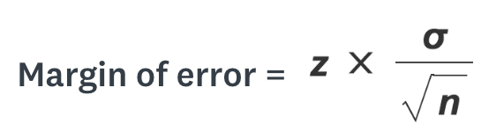

n = 15,

ME = 2.576 $× \frac{0.2}{\sqrt{15}}$

ME $≈ 0.133$

STEP 5: CONFIDENCE INTERVAL

= $\underline{(x } - ME) , (\underline{x } + ME$)

= (1.036 - 0.133) , (1.036 + 0.133)

= (0.903, 1.169)